Packet Tracer - Skills Integration Challenge

**Topology**

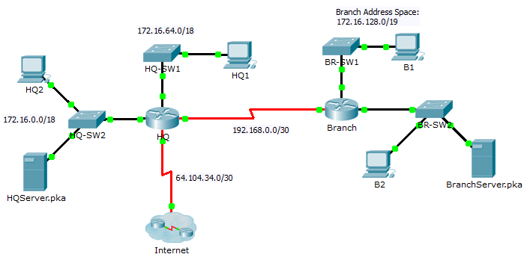

Addressing Table

|  |  |  |  |  |
| --- | --- | --- | --- | --- |
| Device | Interface | IP Address | Subnet Mask | Default Gateway |
| HQ | G0/0 | 172.16.127.254 | 255.255.192.0 | N/A |
| G0/1 | 172.16.63.254 | 255.255.192.0 | N/A |
| S0/0/0 | 192.168.0.1 | 255.255.255.252 | N/A |
| S0/0/1 | 64.104.34.2 | 255.255.255.252 | 64.104.34.1 |
| Branch | G0/0 |  |  | N/A |
| G0/1 |  |  | N/A |
| S0/0/0 | 192.168.0.2 | 255.255.255.252 | N/A |
| HQ1 | NIC | 172.16.64.1 | 255.255.192.0 | 172.16.127.254 |
| HQ2 | NIC | 172.16.0.2 | 255.255.192.0 | 172.16.63.254 |
| HQServer.pka | NIC | 172.16.0.1 | 255.255.192.0 | 172.16.63.254 |
| B1 | NIC |  |  |  |
| B2 | NIC | 172.16.128.2 | 255.255.240.0 | 172.16.143.254 |
| BranchServer.pka | NIC | 172.16.128.1 | 255.255.240.0 | 172.16.143.254 |

Scenario

In this challenge activity, you will finish the addressing scheme, configure routing, and implement named access control lists.

Requirements

* + 1. Divide 172.16.128.0/19 into two equal subnets for use on **Branch**.
       1. Assign the last usable address of the second subnet to the Gigabit Ethernet 0/0 interface.
       2. Assign the last usable address of the first subnet to the Gigabit Ethernet 0/1 interface.
       3. Document the addressing in the Addressing Table.
       4. Configure **Branch** with appropriate addressing
    2. Configure **B1** with appropriate addressing using the first available address of the network to which it is attached. Document the addressing in the Addressing Table.
    3. Configure **HQ** and **Branch** with RIPv2 routing according to the following criteria:
* Advertise all three attached networks. Do not advertise the link to the Internet.
* Configure appropriate interfaces as passive.
  + 1. Set a default route on **HQ** which directs traffic to S0/0/1 interface. Redistribute the route to **Branch**.
    2. Design a named access list **HQServer** to prevent any computers attached to the Gigabit Ethernet 0/0 interface of the **Branch** router from accessing **HQServer.pka**. All other traffic is permitted. Configure the access list on the appropriate router, apply it to the appropriate interface and in the appropriate direction.
    3. Design a named access list **BranchServer** to prevent any computers attached to the Gigabit Ethernet 0/0 interface of the **HQ** router from accessing the **Branch** server. All other traffic is permitted. Configure the access list on the appropriate router, apply it to the appropriate interface and in the appropriate direction.